Quick Group Calling Tips
Small things to do to help improve the Group Call when you have some participants with known low internet speeds or very old devices with slow processors:
1. Whomever is starting the call switch their Video Quality Setting to Low Definition in Account Settings > Room Settings. (not SD or HD)
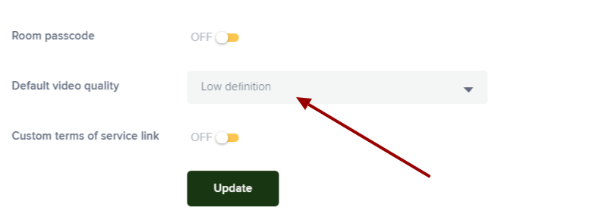
2. Only if possible, try to have group call members join via laptop, desktop, tablet or phone that does NOT require the Safari browser as iOS is not as friendly with other web browser software in the most recent updates. (Use Android or windows with Chrome, Firefox or Edge browsers)
2. If Participants are not speaking please have them Mute their microphones, if they do not need to be seen until talking please encourage them to mute the Mic and Stop their video feed.
3. Make the browser tab you are using for the video call (Chrome, Firefox, Edge, Safari) NOT full screen, reducing the size of the browser window will reduce the pixels displayed, make the image appear clearer and reduce bandwidth used.
4. Please make sure phones, tablets and laptops have a decent battery charge, processing live video calls with a low battery can add a lot of demand to the device and may result in dropped calls or audio issues.
5. This is a little more detailed: High CPU usage is one of the simplest issues that can impact a computer’s performance. If you find that high CPU usage persists—even in support of standard processes—you may simply need a faster computer. You can also reduce CPU load by adding more RAM to the laptop/Desktop, which can give your CPU a much-needed break. More Details
The key things that make for a poor experience on group calls are as follows:
1. Low internet speeds: say below 10-15MPBS on Download or Upload, Latency above 50ms for an optimal: https://speed.measurementlab.net/#/
2. Old Devices with poor processing power (CPU’s) can have a tough time with demanding live video, especially the larger the number of people on the call.
- Phones (iPhone or Android): Around 2-3+ years old
- Tablets: Around 2-3+ years old
- Laptops and Desktops: around 4+ years old
- These Devices tend to have older Operating systems, slower processors, out of date browsers and more.

3. People Connecting on phones or tablets over a cellular network: cellular data plans, in most cases are much slower than WiFi (ask if they can join a WiFi network before the call) If not get the best cellular data plan signal you can. Easy Fixes improve Cell SIgnal
4. Try minimizing the browser size if blurry image, this reduces the image size and makes it appear clearer and takes up less bandwidth
General Group Call Video: https://www.youtube.com/watch?v=F1Ag7YQXVgs

