FILLING OUT EXPENSE FORMS ACCURATELY
Information on the Yamhill County expense form is primarily used for employee reimbursement, but some of the information is also taken from this form and logged into other tracking tools. That information is looked at by County Departments and could be audited by the IRS.

Please fill out the form on the computer so that the formulas in the columns calculate the dollar amounts. This cuts down on calculation errors. These forms are also scanned into Docuware after posting—where character recognition makes them searchable for the information they contain (if they are typed on the computer).

Please note the RED triangles in the corner of some of the boxes. These “comments” are for your reference.

Employee Number – This is a 1-4 digit number only. No letters please.
Employee Name – First then last.
Department – Please list your specific department. PH, CSS, DD, VETERANS, ABH, F&Y, Business Services, Admin, Admin (YCCO).
Date from-Date to – List the dates of the first and last reimbursement that you are claiming.

Please submit your expense reports monthly or semi-monthly. It is very important that you staple receipts to the back of the expense report for scanning purposes.
Receipts are needed for lodging (if paid by employee), parking, meals, and anything other than mileage. In some cases, special needs requests should be attached if purchasing items for clients with personal monies and was not reimbursed by petty cash. (Under $20 can be reimbursed with petty cash).

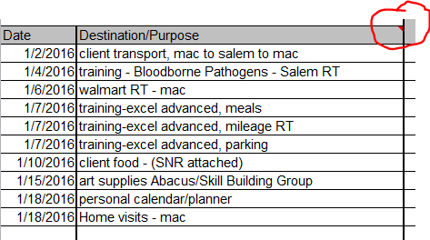
DESTINATION/PURPOSE
Hover over the red triangle for further instructions on what needs to be listed in this column.

Please be as descriptive as possible, but also brief. Do not list client name. If you attended a training, the name of the training must be listed. This information is taken from this form and logged into another tracking form and we need to be able to match them up.

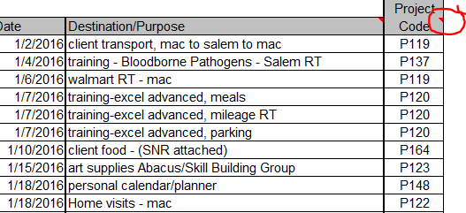
PROJECT CODE COLUMN
All project codes start with the
Letter P (except for PH) and have 3 numbers after it. There should not be any other letters or numbers listed in this column. If you do not know your project code, please ask your supervisor.

Please use your project code for each line. Some employees will have more than one project code that they work under. These project codes are used to code monies to the correct budget code.

PROJECT CODE | DESCRIPTION
P148 | DD - CASE MANAGEMENT
P149 | DD - APS/LA 02
P150 | DD - CONTRACTS
P115 | VETERANS
P120 | ABH - ADULT MH, GENERAL OP, CAT/COS
P160 | ABH - CHEMICAL DEP. - JOINT BJA/SAMSHA
P163 | ABH - CHEMICAL DEP. - FAMILY DRUG COURT
P164 | ABH - ADULT A&D, GENERAL OP
P166 | ABH - CHEMICAL DEP. - TTRS
P119 | CSS - COMMUNITY SUPPORT LIVING, ACT
P123 | ABACUS - PSYCH/SOC, VOCATIONAL
P138 | ABACUS - SUPPORTED EMPLOYMENT
P137 | RTF/ECF - ENHANCED CARE FACILITY
P122 | F&Y - OUTPATIENT, CRISIS/REACH
P125 | F&Y - SCHOOL BASED
P145 | F&Y - JUV ALT. PROGRAM
P165 | F&Y - A&D
P129 | HHS - OHP CONTRACTS
P101 | HHS - ADMIN
P102 | HHS - YCCO ADMIN

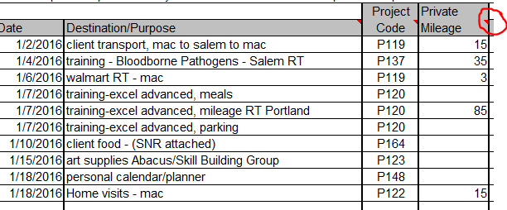
PRIVATE MILEAGE
This is mileage from personal vehicle. ONLY MILEAGE GOES INTO THIS COLUMN. This column automatically calculates mileage expense at bottom of the column.
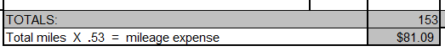
`

Parking receipts do not go in this column. It will affect the calculation at the bottom of the column.

LODGING & MEALS
Hover over red triangles for further instructions.

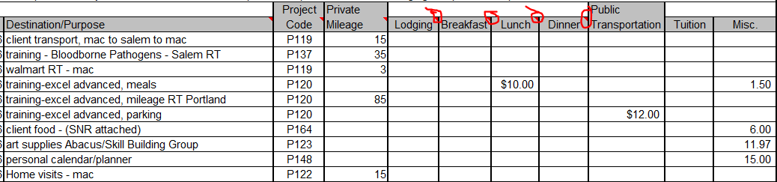
Columns will automatically total. Column totals auto calculate for Total Expense

LODGING - This is usually paid for in advance by the county on an OVERNIGHT REQUEST FORM.
MEALS - Meals will be reimbursed up to the per diem rate listed in each “comment”, unless otherwise noted on an Overnight Request Form. All meal receipts MUST be the itemized receipts that show what was purchased and what your tip, if any, was for. Receipts must be attached to back of expense report. Do not list tips in this column.
PUBLIC TRANSPORTATION – This includes parking receipts and taxi receipts. Receipts must be attached.
TUITION – Registration for classes if not already paid for by County. Receipt must be attached.
MISC. – This column is for everything else not already listed. Tips for meals and transportation, baggage check, supplies, Special Needs Request (SNRs), etc. Receipts and SNR’s must be attached for reimbursement.

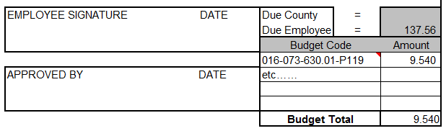
BUDGET CODE/AMOUNT
This section is used by accounting using your project codes you have listed in Project Code Column.

Please sign and date and turn in to your supervisor with your timesheet. Your supervisor will sign at the time they sign timesheets.

If you have any questions, please call Camille Tanaka at extension 4815.

Attached is a copy of Yamhill County Travel Reimbursement Policy.

