INSTRUCTIONS FOR FILLING OUT OVERNIGHT TRAVEL FORMS

When clinicians/supervisors request overnight travel approval, the following is needed to put the packet together for our Director (Silas Halloran-Steiner) and our Board of Commissioners approval signatures.

- Clinician must email supervisor for approval with the following information attached:
  - Training information that includes dates, sponsor, location, purpose of the training and attach an agenda if available.

- Once the email request has supervisor approval, the staff member can fill out the Request for Overnight Travel Form, located on the Intranet (under Finance & Payroll Forms, Travel Request Form). Staff only fills in the boxes with yellow highlights. See attached. Accounting staff will fill in the boxes with blue highlights.

- Once staff fill out their portion, staff will email the approval email from their supervisor, the Overnight Travel form and the agenda, along with any other pertinent information that may be needed in order to make reservations to Camille Tanaka. If Camille is not available, a backup accounting staff (AS) will be assigned.

- Once AS has received the request, AS will make reservations for hotel. Sometimes the training sponsor will recommend a hotel to use with a group rate. Otherwise, find the hotel closest to the training site that is within the Government Per Diem Rates for that state and date of travel. (www.gsa.gov) Use the purchase card to make the reservation and request the government rate. Sometimes it is not always the cheapest.

  - Request that the confirmation be emailed directly back to the AS making the reservation. This will be the receipt for the purchase card and will also be included in the travel packet.
  - Request a Credit Card Authorization Form be sent to you. Fill out and return.

- This is what to look for: (using Bend, Oregon as example) in the gsa.gov website
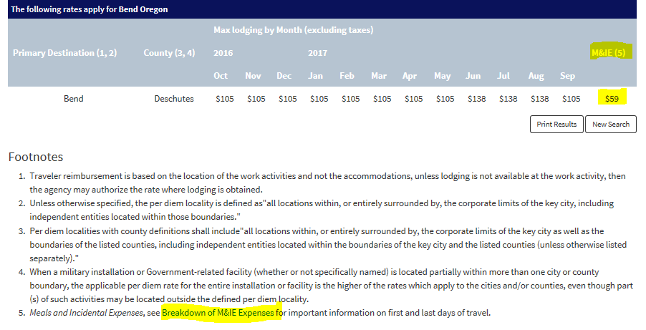
- The rates under the listing of months are the hotel rates per night (see above). The last column (M&IE) is the total daily amount for meals and incidentals. To get the breakdown of dollars per meal, click on the Breakdown of M&IE Expenses (which is highlighted in blue on webpage). Look for the total daily dollar amount. There you will have a breakdown by breakfast, lunch, dinner, and incidentals.

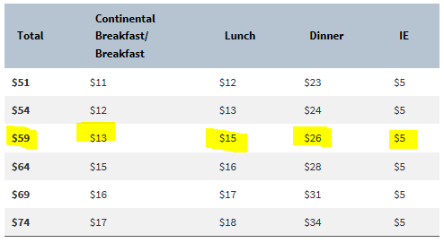

- If the staff member is driving a personal car, the round trip mileage is calculated. This is just an estimate and the staff member will have to track his/her mileage. Mileage is calculated to and from McMinnville or from starting location if it is closer to destination. This is the website used to calculate mileage: http://maps.randmcnally.com/mileage-calculator.do

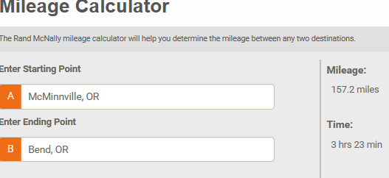

- Transportation: If the clinician is not driving their own personal or county owned vehicle, and will need to have flight arrangements made, Camille will shop for the least expensive flight that allows the clinician to arrive and depart from destination within reasonable time frames. They may even request a certain time of day to travel. Company policy is clinician can arrive day before training and should depart on the last day of the training so not to incur any extra lodging and meal charges. Sometimes this is not feasible. When shopping for flights, Expedia is used most often to compare flight times and rates. Camille will use the purchase card to make the reservation.

- Training Registration: If there is no cost for the training itself, the staff member can register themselves for the training and then forward a confirmation to be attached to the travel packet for approval. If there is a cost for the registration, then the staff member can forward the link to the website and it will be paid with a purchase card. No Purchase Order is needed for the Overnight Travel Packets since it will be signed by both the Director and the Board of Commissioners. If the registration link requires a login/password, have the staff member fill out the registration and the AS can go to their office to pay for the registration.

- The AS will fill in all of the estimated cost boxes and all other blue highlighted boxes that apply.

- Once Camille has received confirmations for lodging, registration and flights if needed, then the agenda and confirmations are attached to the back of the travel request form and turned into Silas Halloran-Steiner, Director, to be signed. He will return to AS. The travel packet will then be taken over to the Board of Commissioners for signature. Once the travel packet is received back, it is scanned into PDF document and filed in the Network Folder: \\yam-main\acct\forms\travel forms\HHS\FY 16-17. The scanned copy will also be emailed to the employee that is traveling so that they have all the address and confirmation numbers necessary for travel.

This is how the form should look when received from the employee traveling: (yellow)

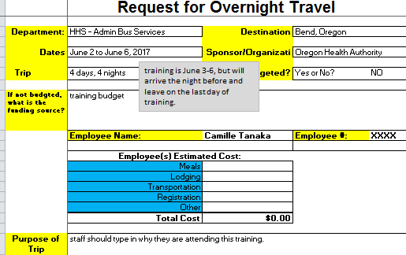

This is how AS will fill out the boxes: (blue)
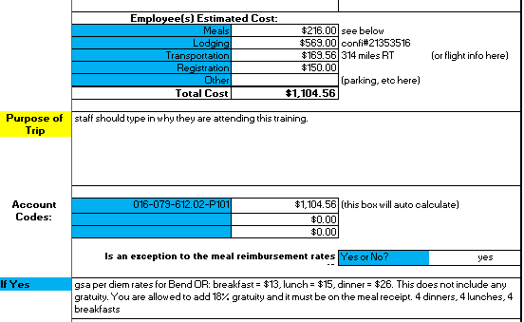
Keep in mind that some hotels offer continental breakfast. The employee will not be reimbursed for meals provided by hotels or by the training sponsors. Employees are allowed to add 18% gratuity to meals and that must show on their meal receipts.

When emailing the approved travel packet to the employee traveling – these are the things that I mention to them in the email: meal cost, gratuity, meals provided by hotel or training host, to track their car mileage, keep all receipts to attach to expense report when they return.

