FILLING OUT A SPECIAL NEEDS REQUEST (SNR) FORM

The following guidelines are broken down into sections. This form is not only used to request money, but is also used to track information on money spent and for which programs, and for tracking client loans. After all information is logged into the appropriate files for tracking, the form is then filed into the clients chart under the Admin Tab.
******BOXES THAT CONTAIN ALL CAPS MUST BE FILLED IN FOR TRACKING PURPOSES**********

PLEASE FILL OUT SNR IN THE PDF FORM ONLINE-we are going paperless in the near future. This also makes it much easier to read and can be sent email to anyone and can also be signed electronically.

SECTION 1 – CLIENT INFO ONLY
Please fill in all boxes with ALL CAPS. If the client is homeless, you can write that in the address line. On the line “Date Funds are Needed” please write check-in and check-out dates for motel stays. On the line “Explain need for funds”, please write a brief description of what the funds will be used for. Examples: Winter clothing for client. Rental application fee. Loan for Rent. One month aquatic center membership. (please do not include the vendor or payee information here)
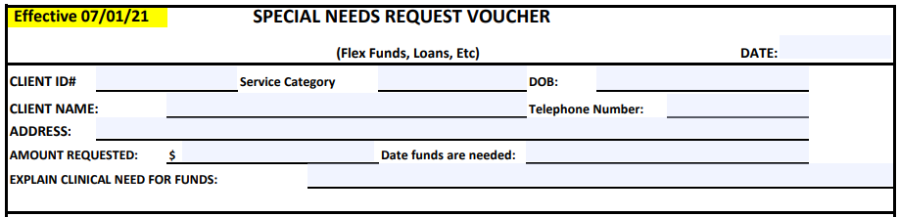

**************************************************************************************************

SECTION 2 – FILL OUT THIS SECTION IF REQUEST IS MEDICALLY NECESSARY ONLY
One of the two lines must be initialed and dated if client has YCCO and will be using YCCO funds. If we are audited for use of flex funds, this section states that you have noted in clients chart that funds were medically necessary.

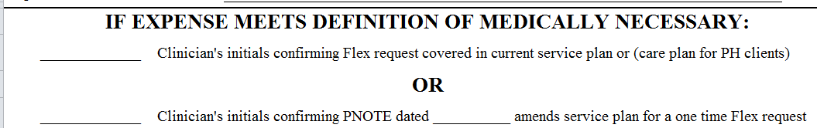

**************************************************************************************************

SECTION 3 – PAYEE/VENDOR INFORMATION
It is very important that this section is filled out every time so that we know who the money is going to. Please do not put a line through this box. If you are not sure if we have a tax id# for the payee, you can call me and I can let you know. If we do not, I will email you a W9 form to send to the payee so that we can get them set up in our accounting system. (See highlighted section on very bottom of form). Sometimes we have more than one address for a payee, so it is important that you fill in the address. Example: Oxford House has four different addresses. If you are getting Bus Passes or Gas Vouchers-you can write Bus Pass or Gas Voucher in the Name field.

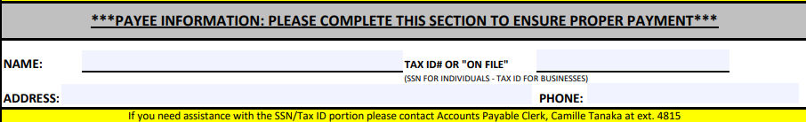

**************************************************************************************************

SECTION 4 – CIRCLE APPROPRIATE USE OF FLEX FUNDS
This section must always be filled in. This is the first step on deciding where the funds are coming from to pay for the SNR. (The second step is under *For Business Services Only*). You will notice there are six gray shaded boxes. Those accounts are for Grant funds use only.

Please note: there are a few new program codes starting 7/1/21.
Newberg, CSS, CAT and F&Y have new codes.
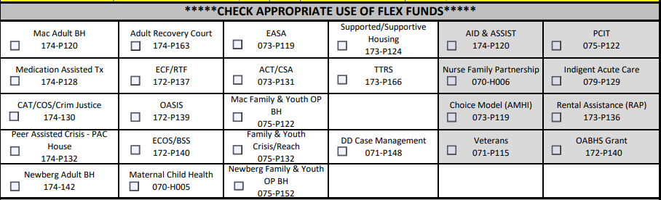

**************************************************************************************************
SECTION 5 – CLIENT LOAN USE ONLY
This section was modified in July 2015 so that more information could be noted and transferred over into the Client Loan File. Please fill in all five lines and then have the client sign and date the document. Funds will not be processed until client has signed for the loan and agreed to the terms stated.

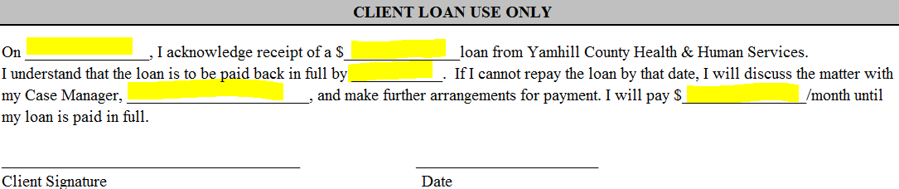

**************************************************************************************************

SECTION 6 – AUTHORIZATION
Person requesting SNR, please print your name so that it is legible and then sign. Then have manager or supervisor sign for approval and date. Supervisors, please see note in RED.

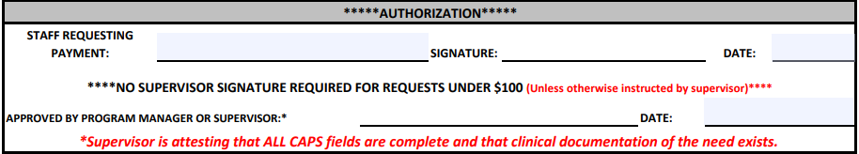

**************************************************************************************************

SECTION 7 – FOR BUSINESS SERVICES ONLY
This section is used to show which account funds we will be using for the SNR. It also shows how the monies will be paid out and a check list of the three places we track the SNR.

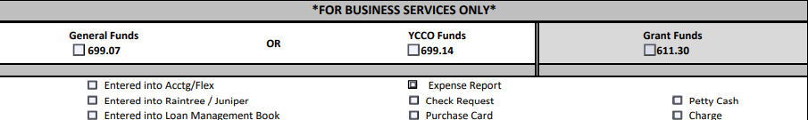

**************************************************************************************************

SECTION 8 – HIGHLIGHTED FOR YOUR ATTENTION – PLEASE READ

