Training Database Workflow/Instructions
- Open the Training DB located in the \\yam-main\hhs\Share\Training folder.
- An employee will open the “Training Request Form Employee”
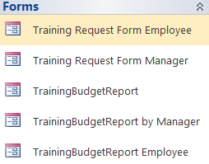
- The employee will then fill out the top portion of the training request form.
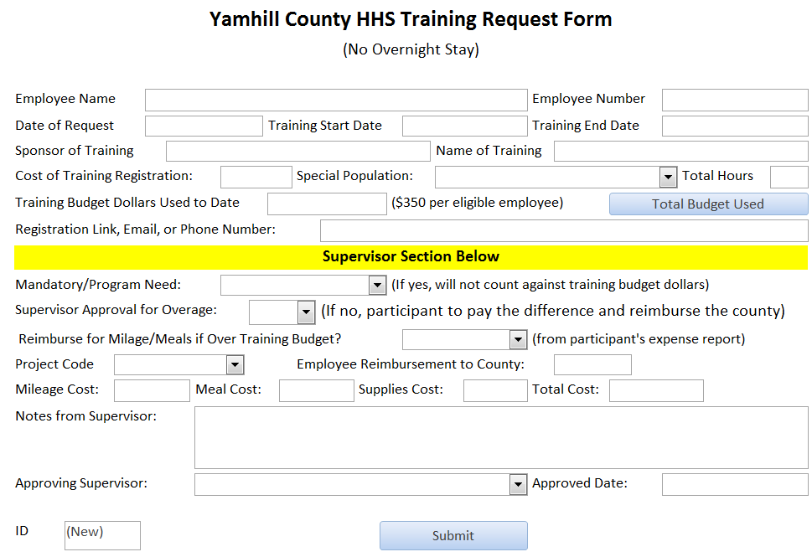

Example of filled out form.
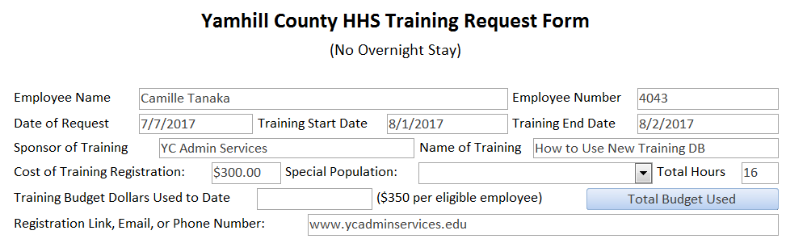
(Note: you can type anything in this box. Email address for registration, the registration website link, “brochure in Camille’s mailbox”, phone number, etc.)

- The employee will then check how much of their budget they have used by clicking the “Total Budget Used” button. If employee has not yet requested and/or taken any training for that fiscal year, the next screen will show up blank. If the employee has already taken training, the form will show the total taken for that fiscal year.
Example 1: No training for fiscal year.
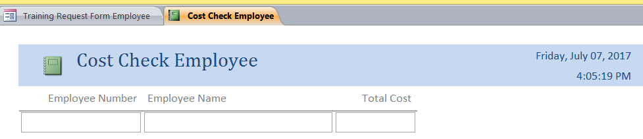
Example 2: Training already logged for fiscal year.
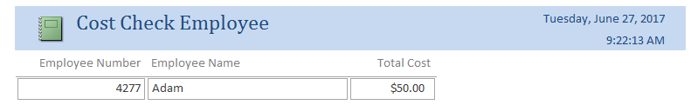
Click on the tab in the upper left corner to go back to form.

- The employee will then finish filling out the portion of the form that is above the yellow line and click the Submit button. Note: if employee does have training dollars logged, then it will autopopulate in the “Training Budget Dollars used to Date” box before form is sent to supervisor.
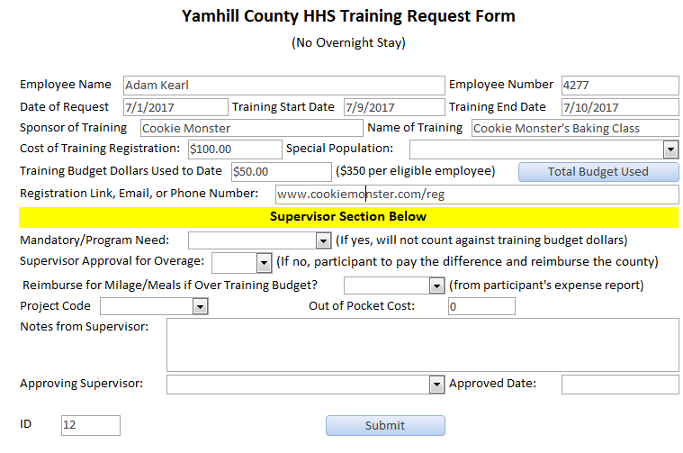
- An email box will then pop up with the form attached. The employee should now send this email to their supervisor for approval. Only send to supervisors. No need to cc: Camille at this time.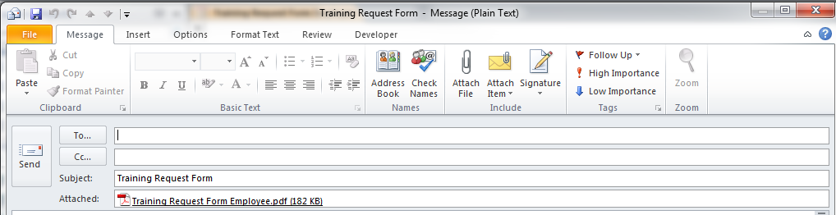

- Once the supervisor recieves the email from the employee (the email only shows that the employee is requesting training and will contain an ID number), they will go back into the “Training DB” (\\yam-main\hhs\Share\Training) and select the “Training Request Form Manager” option. This is the bottom half of the training request form.
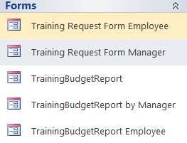

- When the form opens up, it will show the last request that was sent and the supervisor will have to input the ID number that shows on the bottom left hand corner of the form that was attached in the email from the employee. This will pull up the correct form for the manager to finish filling out and approve. Only the boxes with the drop-down arrow, the Notes, and the
Approved Date will be filled in by supervisor. The other boxes are auto-populated from the trainings already logged for that fiscal year. (The Employee Reimbursement to County will automatically calculate once the cost of the training and the amount of their budget that has been used is filled in). Once the supervisor approves and sends the email, the training budget database will be updated with the new numers.
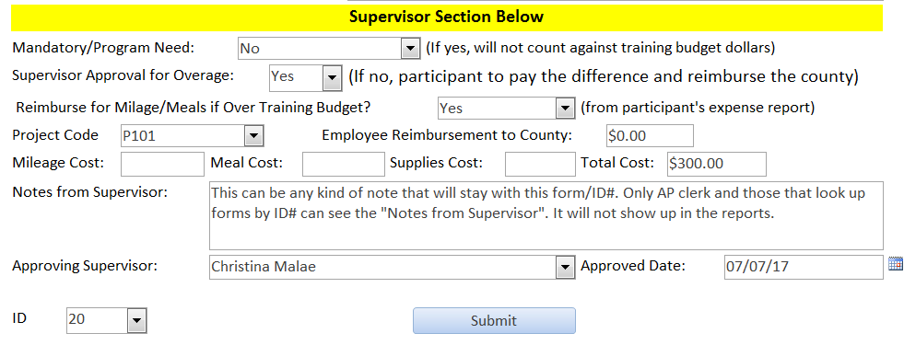
- Once finished the manager will click the submit button and it will bring up an email, with the completed form attached. The email will, by default, be addressed to the Senior Accounting Clerk in charge of AP, Camille Tanaka. The supervisor should then also cc: the requesting employee and send the email. 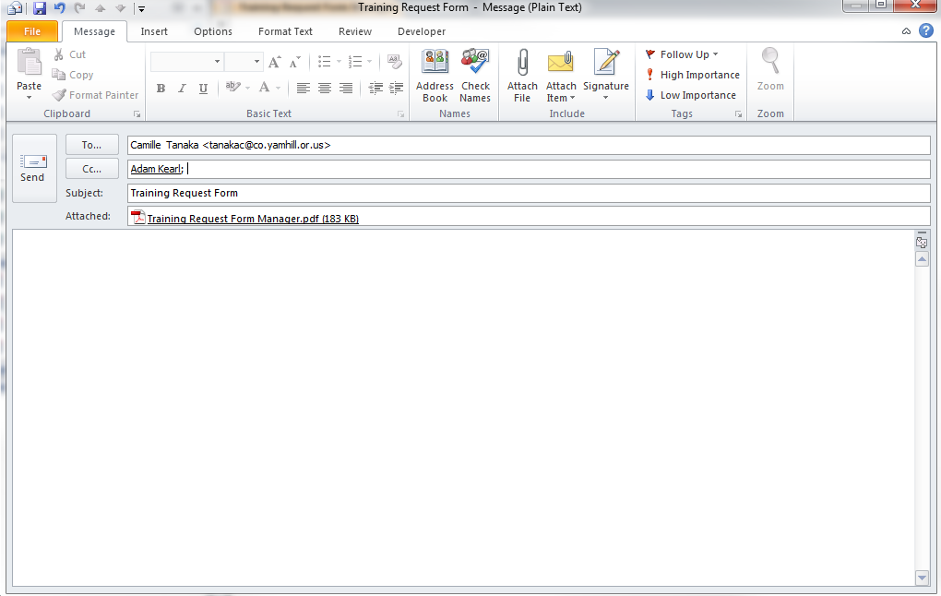

- Once Camille has received the email, she will process a PO request and once approved, she will register the participant for the training and send an email confirmation to the participant. If Camille has any further questions, she will address those questions with the requesting employee.
If you have any questions, please contact Camille Tanaka at ext. 4815.

Note: If you get this message when hitting the Submit button to send the email, please click OK.
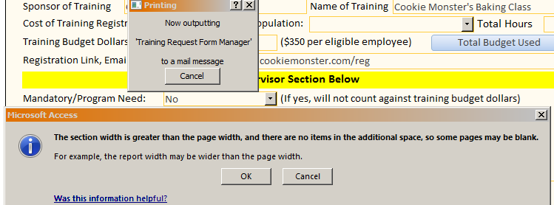

Extra Features:
- TrainingBudgetReport by Manager. This report in the training database will allow supervisors to check how much each of their employees have spent in a certain date range. It will show all employees in which a specific supervisor has approved their trainings.
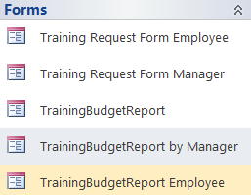
- Fill out the dates and select the name of a supervisor from the drop down list. Once you are finished click the launch report button.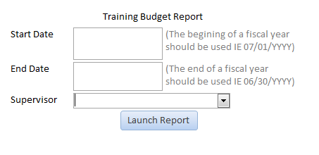
- This report will show all employees that the supervisor has approved training for and the total dollars spent on training will automatically populate. 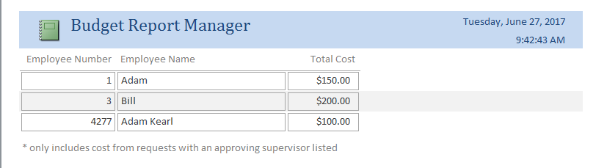

- TrainingBudgetReport Employee. This report in the training database will allow employees and supervisors to check total dollars spent on training for a specific employee.
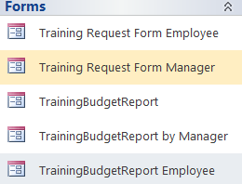

- Enter the employee number and the date range and then launch.
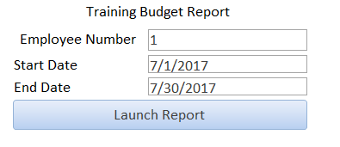
- This is the report that you will receive.
